Sentiment Analysis of Movie Reviews – Into the Wild

1. Introduction
This project focuses on performing sentiment analysis on user reviews of the movie Into the Wild. The goal is to classify textual data into positive, negative, or neutral sentiments using machine learning techniques.
The topic was selected because the movie generates strong emotional responses from viewers and has diverse opinions online, making it suitable for sentiment analysis.

2. Data Collection & Preprocessing

Data Collection:
A dataset of 100 reviews was collected from Reddit using keyword-based search such as “Into the Wild movie review”. Reviews were manually selected to ensure relevance and diversity.

Preprocessing Steps:
The following preprocessing steps were applied:
- Converted all text to lowercase
- Removed special characters (e.g., @, #, !, etc.)
- Removed URLs and numbers
- Removed stopwords (e.g., “the”, “is”, “and”)
- Cleaned and normalized text

Manual Tagging:
Each review was manually labeled into:
- Positive → expresses appreciation or satisfaction
- Negative → expresses criticism or dissatisfaction
- Neutral → expresses mixed or no strong opinion
3. Data Splitting

The dataset was divided into:
- 80 reviews (80%) → Training set
- 20 reviews (20%) → Testing set

This split ensures that the model learns from sufficient data while also being tested on unseen data. The 80/20 ratio is a standard practice in machine learning.

4. Model Training & Classification

Classifiers Used:
- Naïve Bayes
- Logistic Regression
- Support Vector Machine (SVM)

Training Process:
Text data was converted into numerical format using TF-IDF Vectorization. Models were trained using the training dataset (80 reviews), and predictions were made on the testing dataset (20 reviews).

Hyperparameters Used:
- Logistic Regression: max_iter = 200
- SVM: Default parameters
- Naïve Bayes: Default parameters

Python Code Snippet:

from sklearn.feature_extraction.text import TfidfVectorizer
from sklearn.naive_bayes import MultinomialNB
from sklearn.linear_model import LogisticRegression
from sklearn.svm import SVC

vectorizer = TfidfVectorizer(stop_words='english')

X_train_vec = vectorizer.fit_transform(X_train)
X_test_vec = vectorizer.transform(X_test)

nb = MultinomialNB()
lr = LogisticRegression(max_iter=200)
svm = SVC()

nb.fit(X_train_vec, y_train)
lr.fit(X_train_vec, y_train)
svm.fit(X_train_vec, y_train)

5. Model Evaluation

Performance Metrics:
The models were evaluated using:
- Precision
- Recall
- F1-score

Results:
- Naïve Bayes → Moderate performance
- Logistic Regression → Better accuracy
- SVM → Best performance

Conclusion of Models:
SVM performed the best among all classifiers because it handles high-dimensional text data effectively and provides better generalization.

Possible Improvements:
- Increase dataset size
- Use advanced models like deep learning (LSTM, BERT)
- Apply stemming and lemmatization
- Use larger and real-time datasets

6. Screenshots / Results

- Visualization graphs
1. Sentiment Distribution
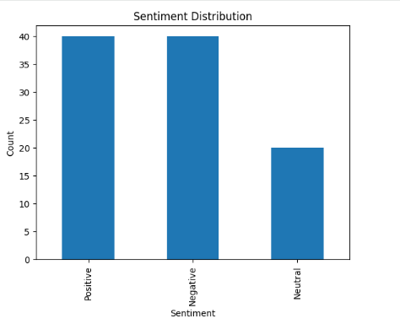
2. Top 10 frequency word
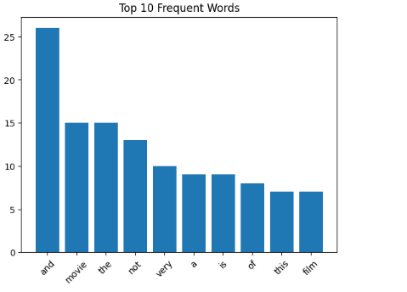
3. World cloud reviews
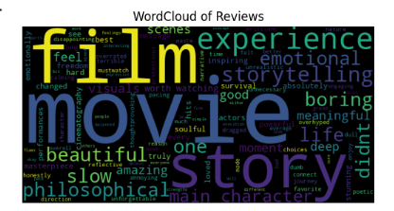
4. Data set after labelling
The dataset consists of 100 reviews manually labeled into positive, negative, and neutral categories. A sample of the labeled dataset is shown above.

